Motion Planning

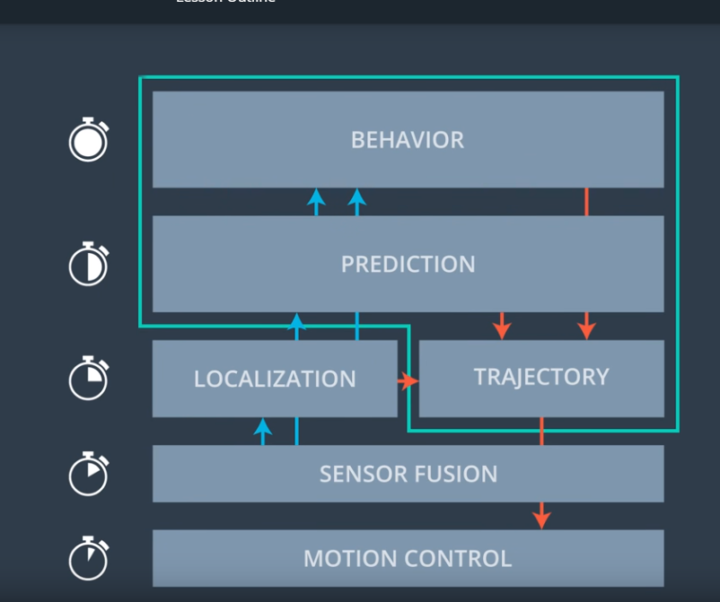

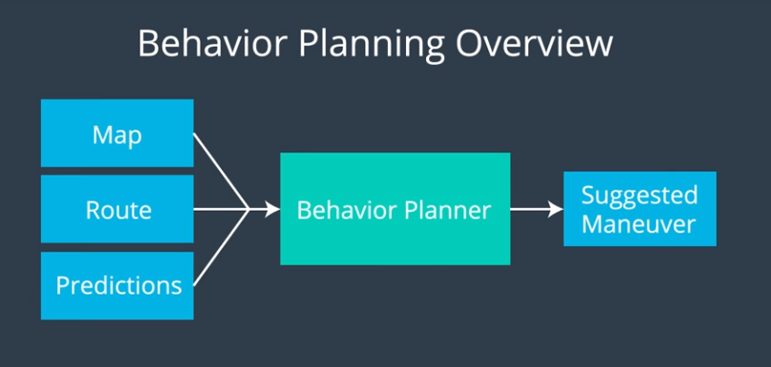

Finite State Machine is used in Behavior Planner

Frenet coordinate

Trajectory Generation

Jerk

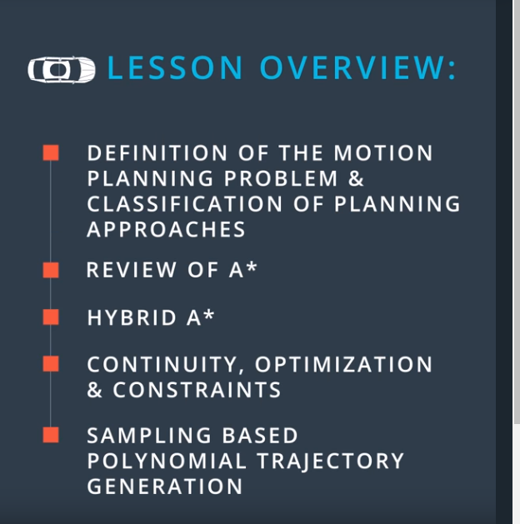

Combinatorial Methods: not good for large-scale

Potential Field Methods: local optimal

Optimal Control: put into one algorithm, numerical complexity

Sampling based methods: easy to compute free space, collision

* Discrete methods: A\*, hybrid A\*
* Probabilistic methods: RRT